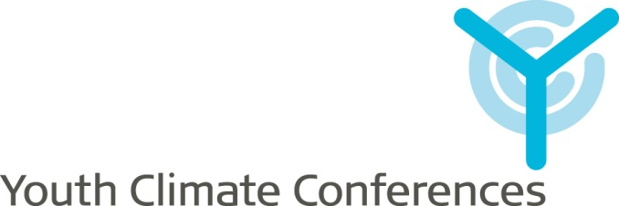

**Guidelines   
for organising a  
YCC Workshop**

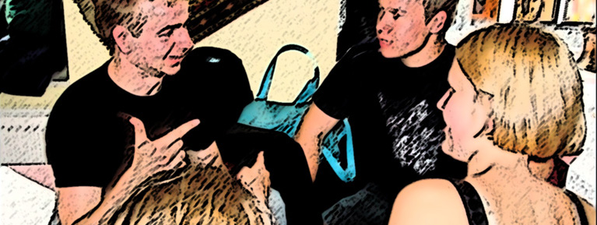

Youth Climate Conferences (YCC) is organised by the Danish Youth Association of Science (UNF) in collaboration with the International Movement for Leisure Activities in Science & Technology (MILSET).

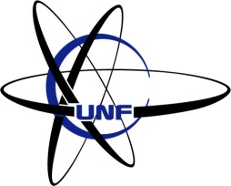

www.ycc2009.org

report@ycc2009.org

March 2009

# Introduction

This document explains in detail how to prepare and conduct a *YCC Workshop*.

**What is YCC?**

The non-governmental, non-profit and politically independent youth organisations UNF and MILSET are organising the Youth Climate Conferences (YCC); the first world event dedicated to visualize the views and the concerns of youth regarding climate topics by regrouping the voices of youngsters from every part of the globe to state a global opinions and actively enter the debate on their future living conditions. It is our intention to encourage youngsters from all around the world to participate in the climate debate. We are confident that the open-mindedness of young people combined with a scientific approach yields important contributions.

**Our goals**

* Set a space where we, the youngsters, can express our concern on climate
* Be engaged in the climate debate that concerns our future and discover our own personal responsibilities
* Express our climate related concerns through various activities
* Present the final result through a statement at the official UN Climate Congress in Copenhagen, scheduled for December 2009

Through the worldwide network of MILSET, we create a space for youngsters to discuss and present their ideas and suggestions about environmental and climate related topics.

Our primary goals will be reached through four types of activities from August 2008 till September 2009 following a common 3 steps methodology: “Observations, Causes and Actions”.

**Types of activities**

* A programme of international and national workshops
* Various activities on the website and a forum where you can share your ideas and thoughts
* An informational campaign with youngsters as the target group

**How to be a good moderator?**

* **Don’t** make the **talk**, moderate it. The youngsters are the ones to do it
* **Keep** a good **overview** on the discussion, what has been said and at which point you currently are
* **Develop** the **report** during the discussions
* Work always concerning about your time limitations
* **Use** moderating or reporting **tools** like mind maps
* **Get** the **support** of the youngsters in your tasks

**How to make a workshop in 4 steps?**

1. **Gather** a group of youngsters
2. **Brainstorm** on observations on climate related topics
3. **Define**, for each of the observations, the cause(s) and possible action(s)
4. **Complete** and **send** the report through the online reporting form or to [report@ycc2009.org](mailto:report@ycc2009.org)

We invite you to take a look at the tips & tricks section at our online forum for organisers which can be found on **www.ycc2009.org**, where you can find ideas on how to organise the work.

We also encourage you to e-mail us with further ideas and inform us about your experiences on what worked well at your workshops!

**How to present the results?**

After your workshop, we would like you to forward us the output through the online form on our website, or by filling out the reporting form and e-mail it to report@ycc2009.org. We need you to:

* Complete the reporting form annexed
* Take some pictures and videos of the activity
* Gather all source materials you think are interesting (mind maps, post-its, etc.)
* If possible, collect information on participants (name, age, nationality, email, level of education)

We accept contributions until the 1st of September 2009!

# About the organisers

**UNF**

The Danish Youth Association of Science (UNF) is a Danish non-profit politically independent organisation of youth with an interest in science. The purpose of UNF is to promote science to youth and give already interested youngsters an opportunity to get an insight into today's science which the school usually is unable to give. The level of difficulty is usually such that everybody who has passed at least the first year of high school (app. 15 years of age) will be able to follow the events with a reasonable understanding and outcome.

We try to promote science in several ways, the main one being lectures and field trips by volunteers from the elite of all fields of science in Denmark. All administration and arranging of lectures and field trips is done by volunteers, usually students, who like to share their spare time with colleagues to promote their common interest.

Every summer since 2002 we have been organising summer camps for high school students in different fields of science, e.g. Biotechnology, Nanotechnology, Mathematics and Game Development. Our Science Camps take place on universities in Denmark during the summer holidays.

**More information at:** [**www.unf.dk**](http://www.unf.dk)

**MILSET**

The International Movement for Leisure Activities in Science & Technology (MILSET) is a non-governmental, non-profit and politically independent youth organisation, which aims at developing scientific culture among young people through the organisation of science-and-technology programs, including Science Fairs, youth congresses, science camps, science contests and experimental activities of high quality as well as training programs and knowledge transfers between member and partner organisations.

Created in 1987, on the occasion of an International Science Fair for Young Researchers held in Québec; MILSET has been presenting a constant and impressive growth regrouping nowadays over 130 organisations from 90 countries dealing with science & technology non-formal and/or extra-curricular education and regrouped in five regional platforms: MILSET Africa, MILSET Amlat (Latin America), MILSET Europe, MILSET Noram (North America) and MILSET Asia.

**More information at:** [**www.milset.org**](http://www.milset.org)

# Practical info

**Time period**

The activities are to be held until 1st September 2009

**Website**

www.ycc2009.org

**Coordinating committee**

Youth Climate Conferences

info@ycc2009.org

**Project Manager**

Danny K. Malkowski

danny.malkowski@ycc2009.org

**Coordinator of International Affairs**

Antoine van Ruymbeke

antoine.van.ruymbeke@ycc2009.org

# YCC reporting form

Please report us, if possible, in English; French, Spanish and Arabic are also accepted. The documents to be in one of the following format: .pdf, .doc, .docx, .txt, .odt.

**Information**

|  |  |  |  |  |  |  |  |  |
| --- | --- | --- | --- | --- | --- | --- | --- | --- |
| Name of the activity |  | | | | | | | |
|  |  | | | | | | | |
| Organiser(s) |  | | | | | | | |
|  |  | | | | | | | |
| Location |  | | | | | | | |
|  |  | | | | | | | |
| Level | Regional  National  International | | | | | | | |
|  |  | | | | | | | |
| Dates | From |  | To |  |  |  |  |  |
|  |  | | | | | | | |
| Participants | 6-12 |  | 12-18 |  | 18-30 |  | Total |  |
|  |  | | | | | | | |
| Gender | Male |  | Female |  |  |  |  |  |
|  |  | | | | | | | |
| Participating countries |  | | | | | | | |
|  |  | | | | | | | |
| Contact person |  | | | | | | | |
|  |  | | | | | | | |
| Contact email |  | | | | | | | |
|  |  | | | | | | | |
| Description of the activity |  | | | | | | | |
|  |  | | | | | | | |
| Comments |  | | | | | | | |

**Results**

|  |  |  |
| --- | --- | --- |
| **Observations** | **Causes** | **Actions** |
| *Ex: We have not received results from a country* | *Ex: There is no workshop in that country* | *Ex: Organise a workshop!* |
|  |  |  |
|  |  |  |
|  |  |  |
|  |  |  |
|  |  |  |
|  |  |  |
|  |  |  |

Once you have completed all forms please submit it to **report@ycc2009.org** together with pictures and other relevant material from your workshop!